**Practical No 7:**

Recovering and Inspecting deleted files:

1. Delete the File from the Drive.
2. Open the Drive with Encase.

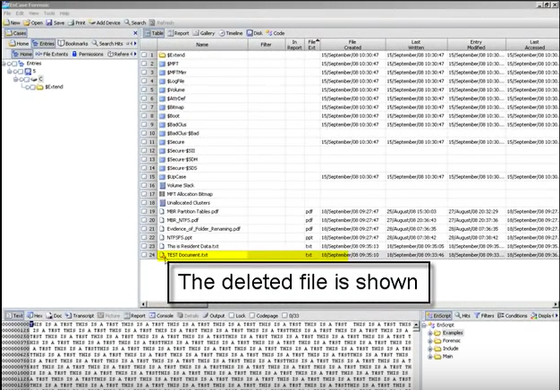

1. The deleted File has a red Circle with a line through it. This depicts a deleted file in Encase.



1. The window below shows the content.

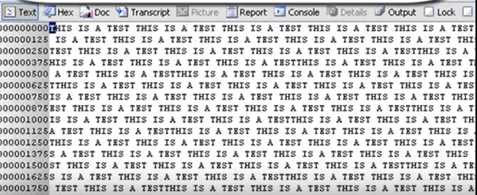

1. To recover the file right click on the file and select “Copy/Unerase.

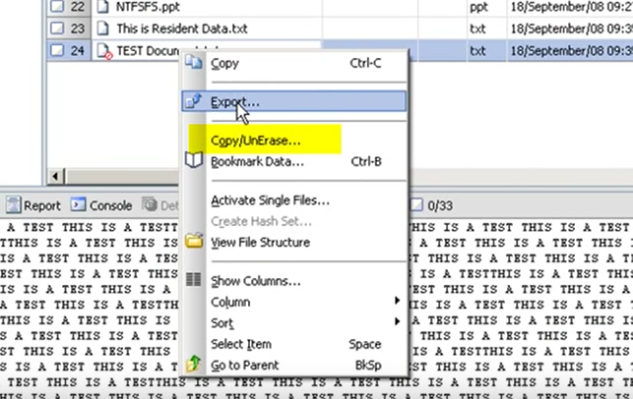

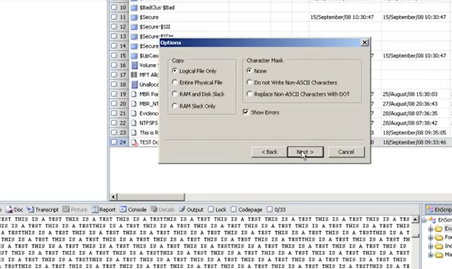

1. Write the location the file will be copied out to:

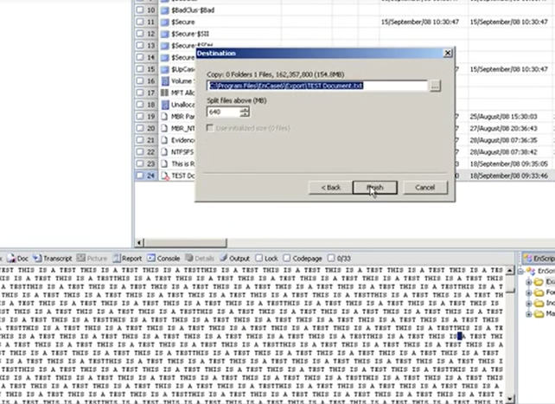

1. The indicator should show how long the file will take to copy out.

The time wil depend on the size of the file being copied out, the speed of the connection to the source and to the destination.

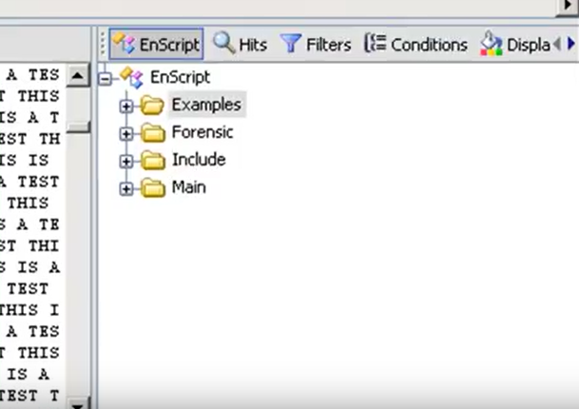

1. Once the extraction is completed Encase will confirm this and any errors.

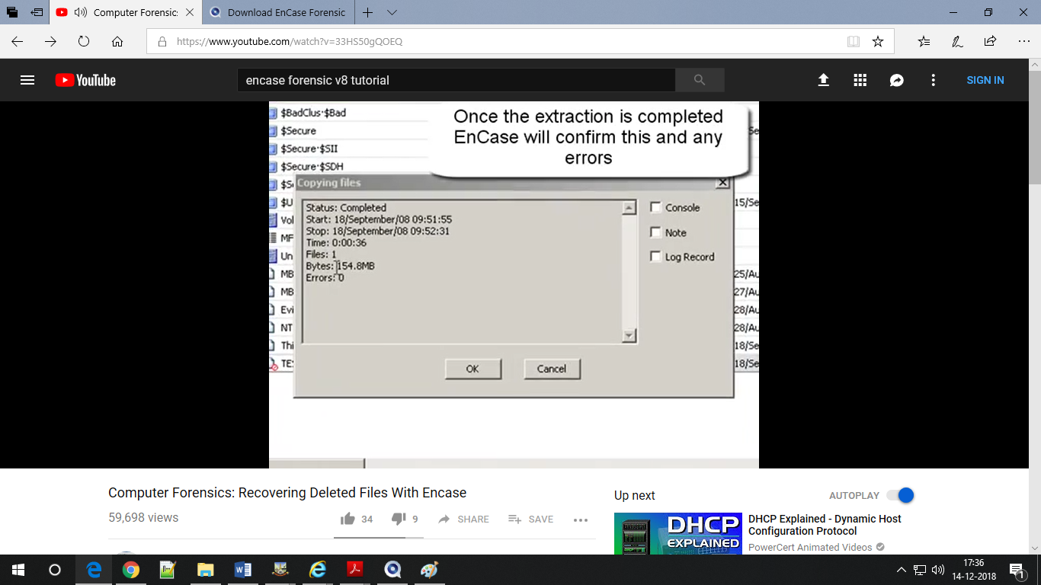

1. Once the copyout has been completed, navigate to the folder where it was extracted to and view the file.